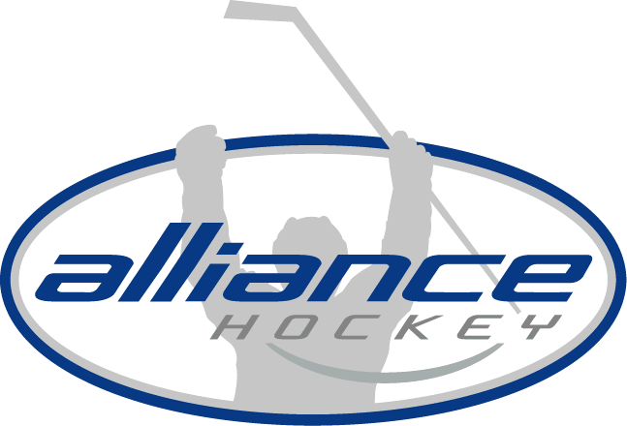

INFORMATION BULLETIN
#2018-05

ALLIANCE HOCKEY
71 Albert Street
Stratford, Ontario
N5A 3K2
Tel (519) 273-7209
Fax (519) 273-2114
www.alliancehockey.com
alliance@alliancehockey.com

TO: Representative & Recreational Council Reps

DATE: June 20, 2018, First released - September 1, 2015, annually updated

RE: Non-Sanctioned Hockey Associations

ALLIANCE Hockey Member Associations are sanctioned by the Ontario Hockey Federation and Hockey Canada which provides insurances for all Hockey Canada and USA Hockey sanctioned events. Member Association teams shall only participate in Hockey Canada and USA Hockey sanctioned events.

Hockey Canada and USA Hockey non-sanctioned organizations include:
Canadian Independent Hockey Federation (CIHF) Ontario Rep Hockey League (ORHL)
Amateur Athletic Union (AAU) North American Association (NAA)
American Special Hockey Association (ASHA) London Red Circle
Sudbury Playground Greater Metro Junior Hockey League
Canadian Elite Junior Hockey League Barrie Slingshots (BCHL)
South Western Ontario AAA team (attempting to participate in the Great Lakes Hockey League which is sanctioned by USA Hockey)

Ontario Rep Hockey League (ORHL) - Potential Associations and Teams:
Brant County Phantoms Burlington Bruins
Peel Predators Hamilton Steelcats
Cambridge Renegades Niagara Knights
London Cobras (Stratford Cobras) Tri-City Titans (Gold/Black)
Carlisle Chill

Please distribute this Information Bulletin to your teams.

Kind regards,

Tony Martindale
Executive Director, ALLIANCE Hockey

