# Information Bulletin: 2019-06

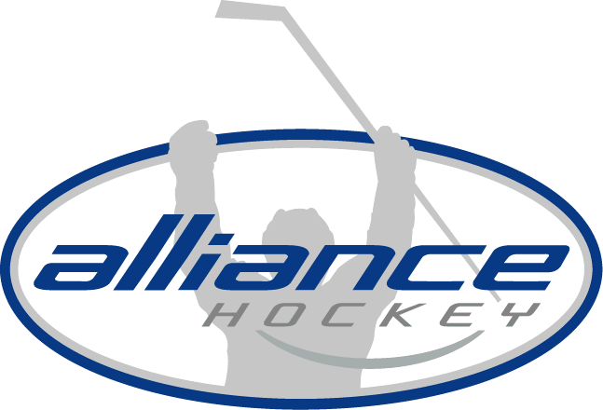

## ALLIANCE HOCKEY

71 Albert Street

Stratford, Ontario N5A 3K2

Tel (519) 273-7209  
Fax (519) 273-2114  
www.alliancehockey.com

alliance@alliancehockey.com

**Via Email**

**Via Facsimile**

TO:ALLIANCE Hockey Minor Development Teams: East/Central and West Leagues

FROM:Tony Martindale  
DATE:August 16, 2019 (Revised February 25, 2020)

**RE: Qualifying for the 2020 ALLIANCE Hockey MD Championships**

**Qualification for MD Championships – Greater London Hockey Association:**

At the December 2, 2009 Representative Council Meeting, the following Motion was passed:

*“To qualify for the MD Championships with the exception of the Host Centre, all other teams must win their Play-down Semi-Final round.”*

**Novice and Atom Pathway Implementation 2020-21 Season**

In preparation for the Novice and Atom Pathway all 27 Novice teams and all 12 Minor Atom Teams will attend the MD Championships.

At Novice there are 27 teams. These 27 teams will be divided into 3 divisions for participation at the MD Championships: Tier 1, Tier 2 and Tier 3.  We will be placing teams in Tiers where they will be competitive based on League play.

At Minor Atom all 12 teams will participate in the MD Championships where teams will be divided into 3 tiers; Tier 1, Tier 2 and Tier 3 based on League play.  All Tiering will be determined the Week of March 9th.

Below is a registration link for the MD Championships; all Novice and Minor Atom MD teams need to register as soon as possible: <https://alliancechampionships.com/Tournaments/2174/Pages/1673/Registration/>

If for some reason you have a Novice or Minor Atom MD team that is not participating please contact Tyler Tolton at [ttolton@alliancehockey.com](mailto:ttolton@alliancehockey.com).

**Novice MD – Tier 1, Tier 2, Tier 3:**

In the Novice Division, there will be 3 Tiers with the number of teams in each Tier to be determined.

**Minor Atom MD – Tier 1, Tier 2, Tier 3:**

In the Minor Atom Division, there will be 3 Tiers with 4 teams in each Tier.

**Qualifiers from West MD League:**

At the Atom through to Bantam Divisions: two teams will advance to the respective Tier 1 and Tier 2 Championships.

The first-place team from the Regular Season and the Playdown Champion will advance to the Tier 1 Division at the MD Championships.

If the first-place team from the Regular Season, is also the Playdown Champion, the Playdown Finalist will assume the second berth.

The next two highest seeded teams upon the conclusion of the Playdown Semi-Finals, will qualify for the Tier 2 Division.

**Qualifiers from East/Central MD League:**

At the Major Atom Tier 1 through to Bantam Tier 2 Divisions: all Playdown Semi-Final winners will advance to the respective Tier 1 & Tier 2 Divisions.

**MD Minor Midget:**

Upon conclusion of the Regular Season (27 games), a divisional split occurs with the 7 teams from the East and the 4 teams from the West. The East will have 3 teams in Tier 1 and 4 teams in Tier 2. Both divisions (East & West) will play a home and away series, which is considered the Playoff Round.

**East Minor Midget MD**

**Tier 1 Playdowns:** Following the Playoff Round, the Playdown Semi-Final will feature 2nd vs 3rd in a best 2 of 3 Series. The loser is eliminated from Playdowns (and any further competition). The winner advances to the Playdown Final vs 1st place finisher the Playoffs in a best 2 of 3 Series. Both teams qualify for the Tier 1 Championships.

**Tier 2 Playdowns:** Semi-Final A:1st vs 4th and Semi-Final B: 2nd vs 3rd. Semi-Finals are the best 2 of 3 Series. The Playdown Semi-Final winners play in the Playdown Final and both advance to the Tier 2 Championships.

**West Minor Midget MD**

Following the Playoff Round, Playdown Semi-Final A:1st vs 4th and Semi-Final B: 2nd vs 3rd. Semi-Finals are the best 2 of 3 Series. Semi-Final Playdown winners advance to the Tier 1 Championships and the Semi-Final Playdown losers advance to the Tier 2 Championships.